Gabcast
http://gabcast.com/

Gabcast is a freeware that allows you to record podcasts from your phone.
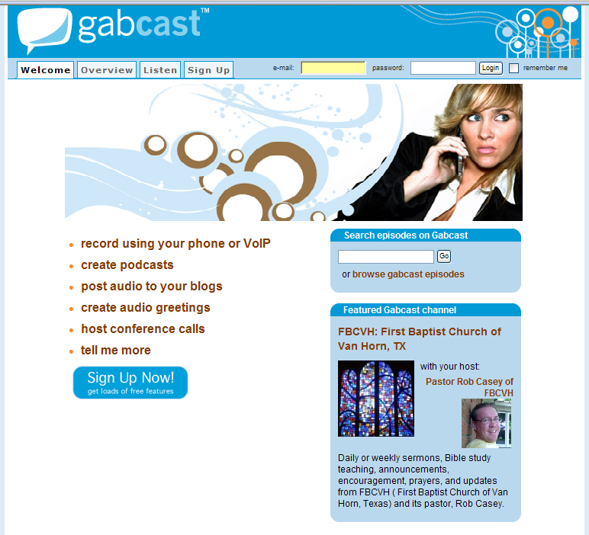
- Logon to Gabcast.com

- Click on Sign Up

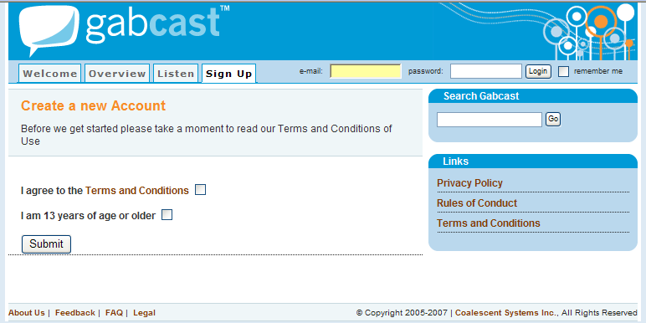

- Agree to the Terms and Conditions and the fact that you are 13 years of age or older

- SUBMIT

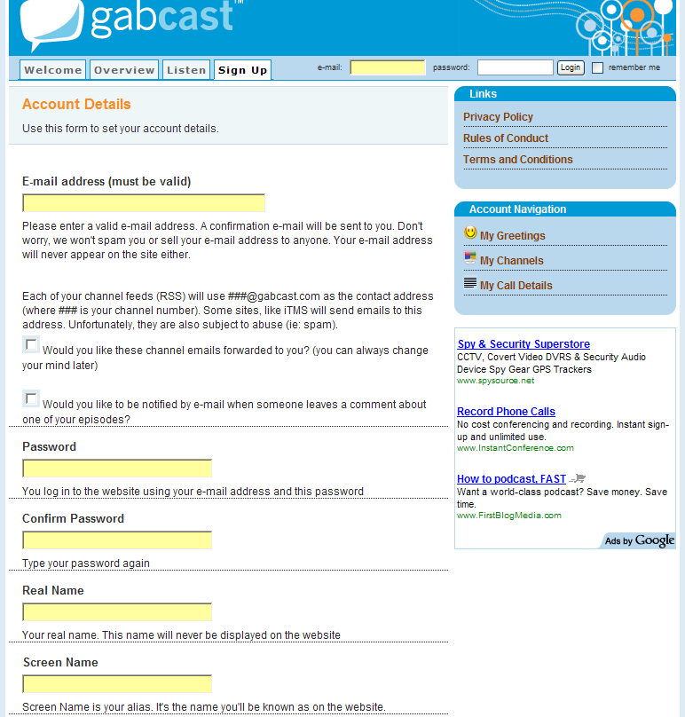

- Fill out the Account Details
- Use school e-mail address
- Check both boxes
- Create a password and re-type it
- Type your real name (first name only)
- Screen Name: I usually do my first initial followed by my last name
- Web Site: optional, you can put your school website
- Profile Image: only if you want one
- Any feedback yet?

- SUBMIT

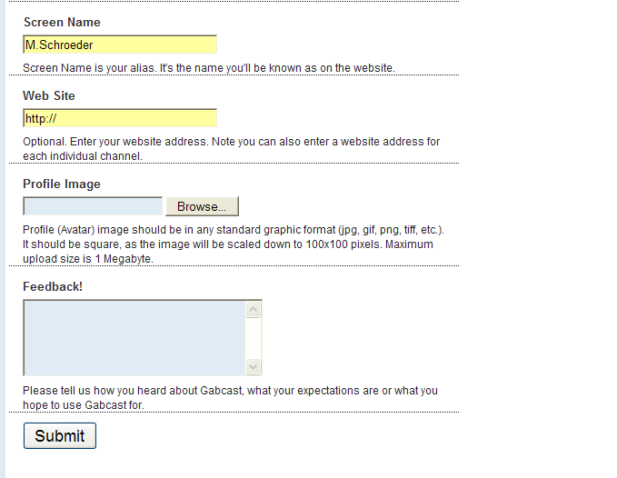

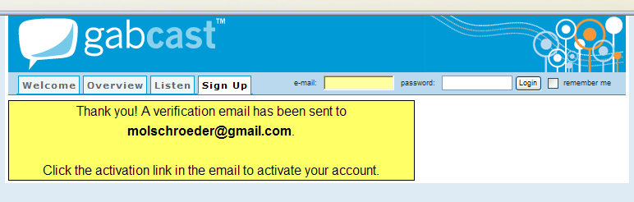

- Gabcast will send you a confirmation e-mail at the account you registered with.

- Check your e-mail and click on the link to verify your account.

- When you click on the link it will take you to Gabcast.

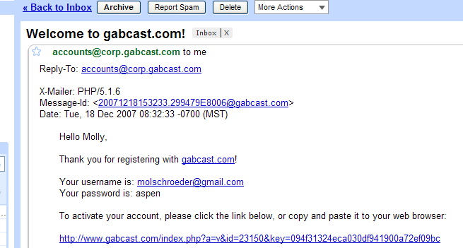

- Login using your e-mail and password

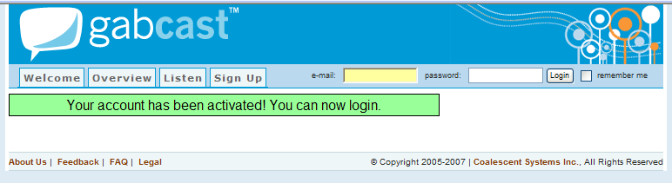

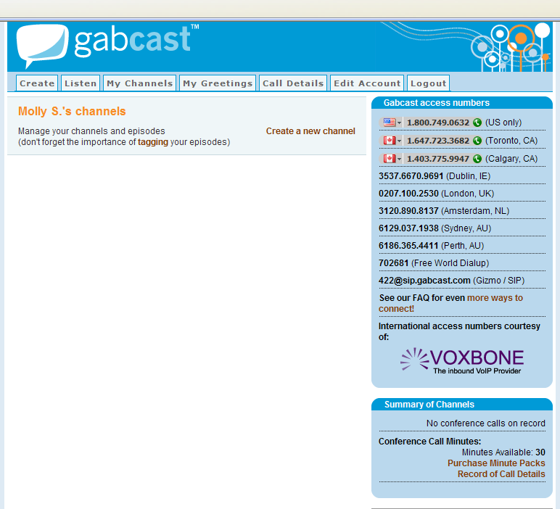

- This is your Gabcast home screen.
- The students will need the (US) 1-800 number listed on the top to call their podcast into Gabcast.
- First you need to create a new channel…click on the words “Create a New Channel”
- You will be able to create multiple channels on your Gabcast account…you can create a channel for each podcast project you do

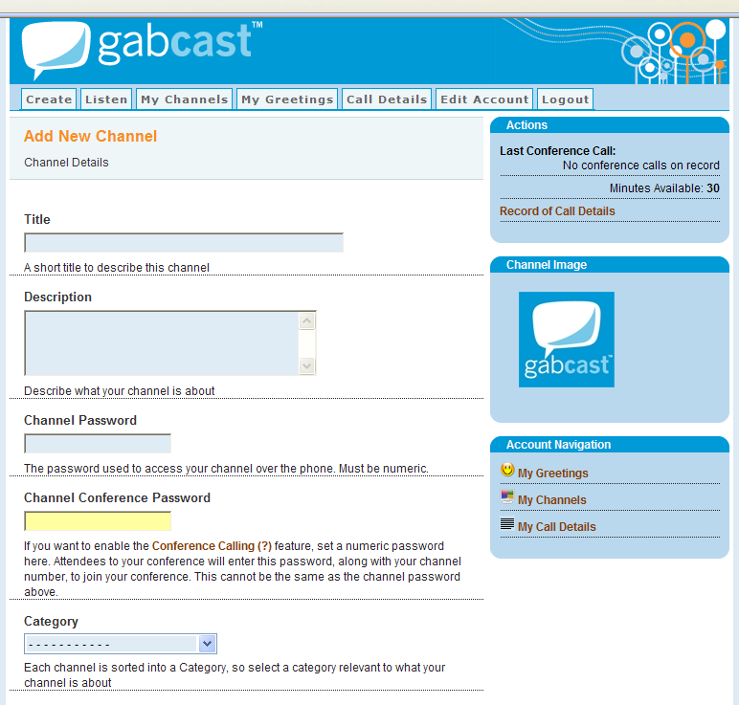

- Title the Channel to match your project for podcasting
- Provide a description of the assignment
- Create a numerical password that you will give to the students to enter the channel…it can be as long or short as you’d like
- Skip the Channel Conference Password
- Choose Education K-12 for your Category
- Type in a few keywords that match your title or description
- Channel Web site: Optional
- Leave Explicit Content unchecked
- Leave Disable Comments Unchecked
- Optional: Channel Image
- Lock the Channel if you prefer to have a little more secure channel (read the directions carefully)
- You can grant access to your blogger account if you already have one by Adding a new blog
- SUBMIT

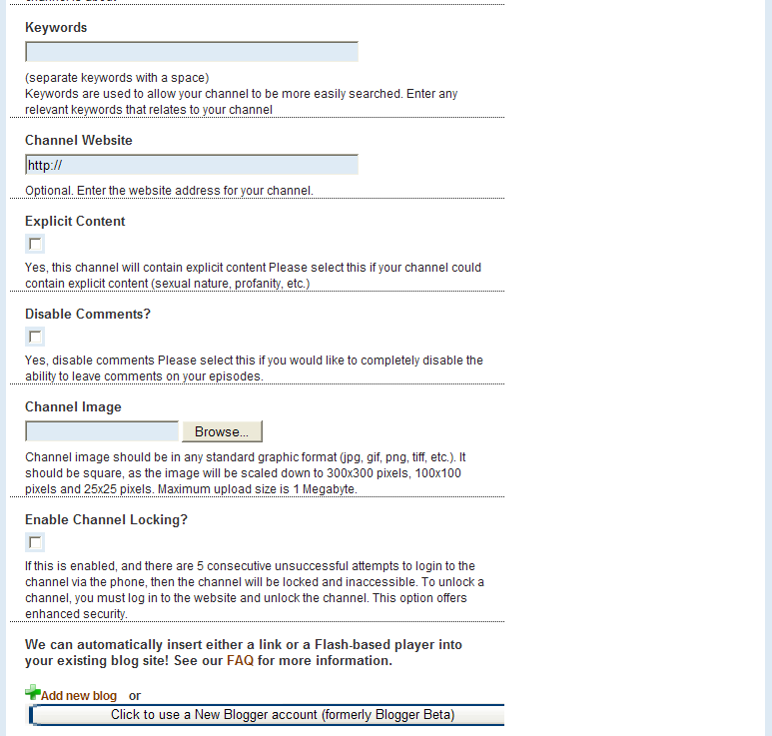

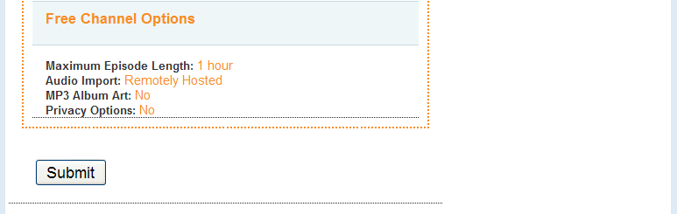

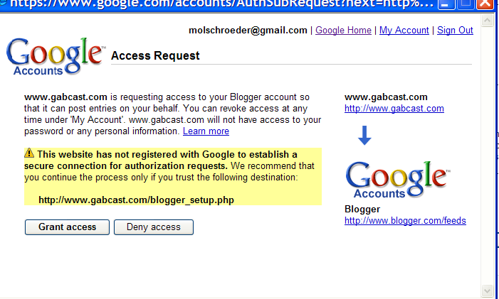

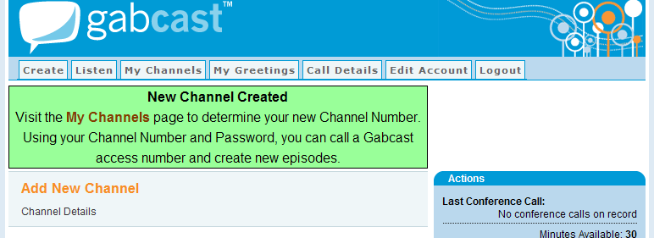

- You will get a notification that your New Channel has been Created
- Click on the Words MY Channels either in the green box or from the tabs across the top of the screen

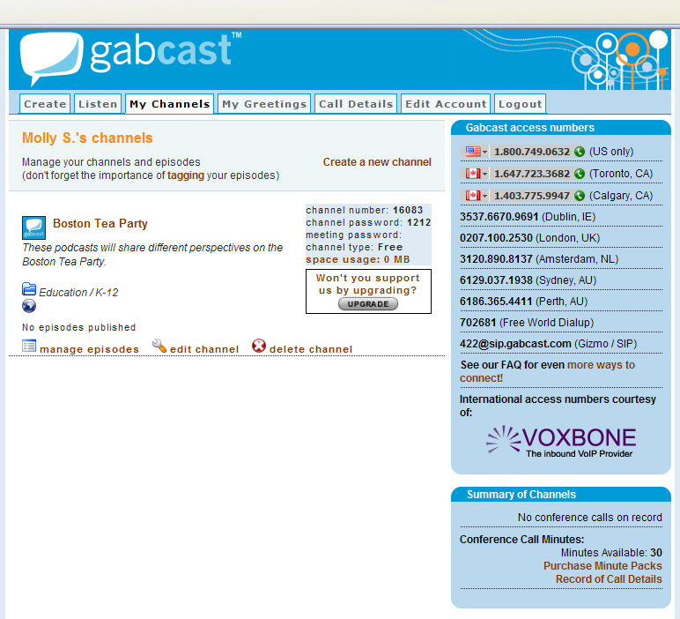

- Here you will get all your new Channel information for the students to publish their podcasts
- To Test this channel Call the 1-800-749-0632 phone number

- Next the enter the Channel Number followed by the # key

- Next they enter the channel password followed by the # key

- Push 1 to record a new episode

- Begin recording your test podcast at the tone and push # when finished

- When finished, push 2 to publish

- After you have published, hang up and refresh your Gabcast webpage and you will see your latest recording on the website

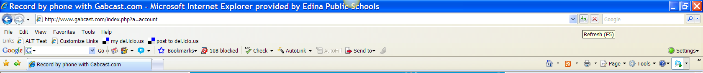
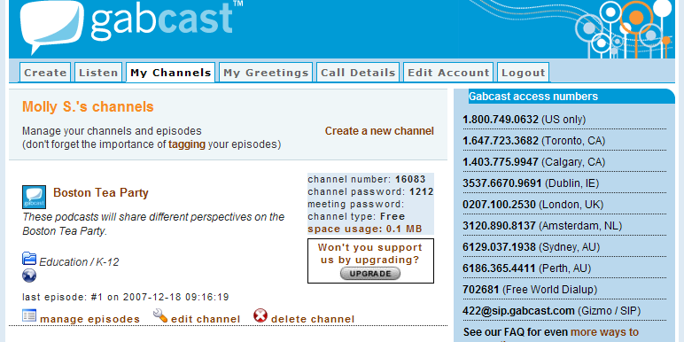

- Click on Manage Episodes

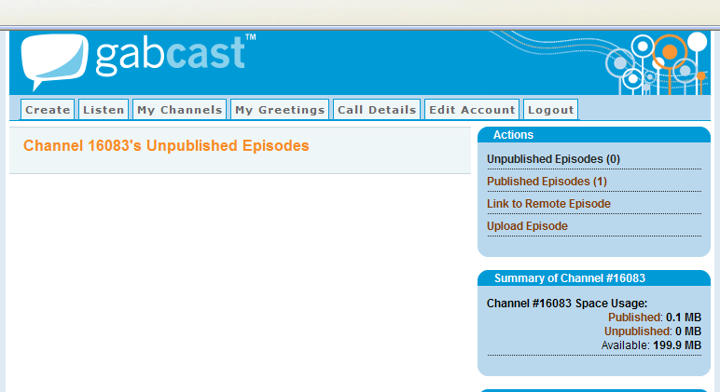

- Click on Published Episodes

- Click on the Tag icon to name your podcast, give it a description and label it with key words
- The red circle with the X is to delete the podcast
- Player Html gives you a code to embed your podcast in your blog or webpage
- Right click on the mp3 button and “Save Target As” so you can save the podcast to your H:Drive or Right Click on Download file and “Save Target As” to your H:Drive
- Hit the play button to hear your podcast

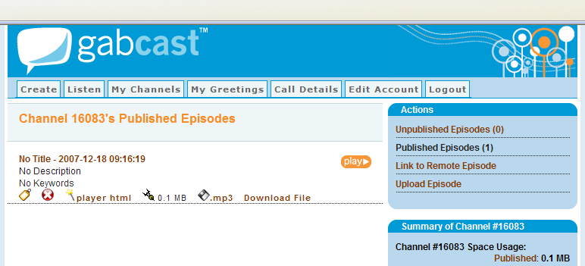

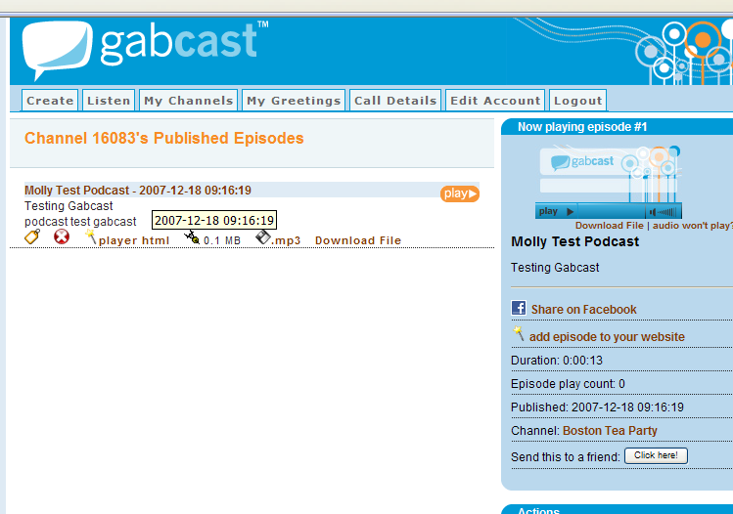

- When you click on the title of your episode you get a few new options for this podcast
- Grab the HTML code to embed this podcast episode in your blog
- Share this podcast with a friend in an e-mail
- Share you podcast on Facebook

So essentially, that is Gabcast. Have your students record podcast using the phone, make sure to title/tag each episode and allow students to listen to their podcast or other students podcasts.

What should I do with these Podcasts when I am done?
Options:
- Right Click on mp3’s or Download File and “Save Target As” to your H:Drive, Blog, Wiki, Webpage
- Add Episode to your website: grab the embedded code and add this to your Blog

MORE ON NEXT PAGE

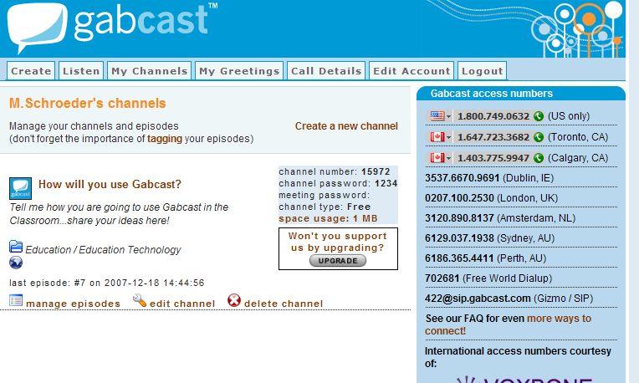
SHARING YOUR GABCAST PODCASTS WITH STUDENTS AND PARENTS:

- Click on My Channels, Click on the Title of your Channel, copy and past the website address and send the link in an e-mail to your parents and students so they can listen to the podcasts

- Click on My Channels, Click on the Title of your Channel, copy and past the website address and past the link on your webpage, Blog or Wiki so students can access the Channel website and listen to their podcasts

- When you have clicked on My Channels, Clicked on the Title of your Channel you will view the website with the following options:
  - Anyone can subscribe to the RSS feed of this channel website…they will be notified of any other podcasts
  - People can leave comments about particular podcasts

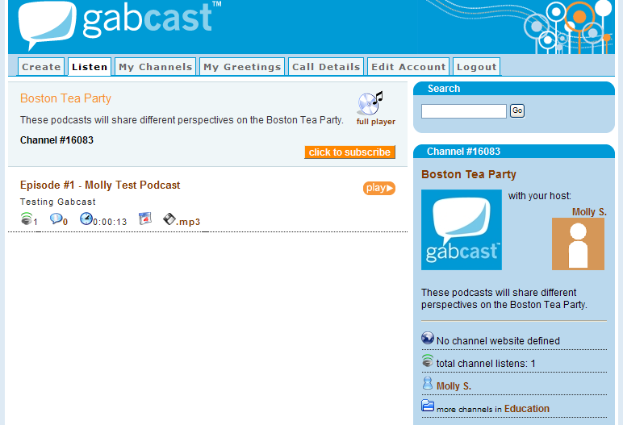

Have fun and let me know how YOU are using Gabcast in the classroom!
molschroeder@edina.k12.mn.us

